Introduction to Carnivorous Plants and How to Grow Them

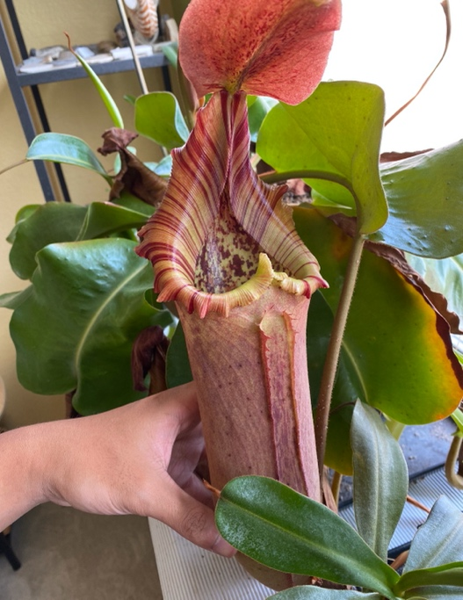

Abstract
My goal is for students to learn about the diversity of carnivorous plants and how to successfully grow them.

Number of students: 25 max
Age group: Any
Time:50 minutes
Format: PowerPoint (not completed yet)
No prerequisites

Introduction (10 minutes)
We will begin the session by discussing what got us interested in carnivorous plants. We will then go over the basic horticultural needs that all carnivorous plants have in common. Topics that will be discussed include the components of carnivorous plant soil mixes, water needs, light needs as well as the feeding regime for the plants.

Major Groups and Cultivation (30 minutes)
We will spend the majority of the session discussing the major groups of carnivorous plants and showcasing their incredible diversity in ecology and morphology. A large array of species and genera will be discussed, ranging from the famous Venus flytraps and sundews to the lesser-known Australian pitcher plants. For each group, we will talk about their natural habitat, ecology, as well as how they trap their prey. We will also focus on care tips that are specific to each species in addition to the general tips provided in the introduction. We will also draw connections on how ecological aspects of the plant influences its horticultural needs.

Lots of interesting images will be included in the slides of plants in their habitats and students will be encouraged to ask questions throughout the presentation.

Resources (5 minutes)
Near the end of the presentation, we want to introduce students to a variety of resources they can use if they want to learn more about carnivorous plants and their cultivation.

Questions (5 minutes)
We will reserve the last 5 minutes for questions. We may also bring in carnivorous plants for students to examine, although we cannot confirm this at this point.

